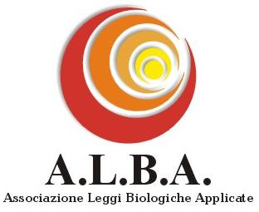
DECLARATION IN FAVOUR OF THE REQUEST FOR SCIENTIFIC ACKNOWLEDGEMENT
OF THE BIOLOGICAL LAWS DISCOVERED BY DR. HAMER

I the undersigned:

Country of residence:

E-mail:

Occupation:

in full possession of my mental faculties, DECLARE that I:

□ am acquainted with the 5 Biological Laws discovered by Dr. Ryke Geerd Hamer.
□ have verified their correspondence with the cases I have experienced.
□ have personally benefited from the application of the biological laws during my disease.
□ am a person who, on the basis of my knowledge, experience and documents read, deems it right and proper that the scientific world strive for a definitive acknowledgement of the verification of the Biological Laws discovered by Dr. Hamer.

For this reason I ASK

the scientific community and the competent bodies to acknowledge the validity, and scientific nature, of the Biological Laws discovered by Dr. Hamer, on the basis of both the scientific verifications already effected, and the possible further ones that may be requested by the competent authorities.

Signature:

Date:

“Report to the senses of article nr 10 of Law 675/96"
Concerning the aims of collection and treatment of the data contained in this agreement, this is to advise that the data provided will be used only for the accomplishment of the purposes of the undersigned declaration, and will be communicated to subjects that carry out tasks for us. With regard to the treatments mentioned above, it’s licence of the undersigned to exercise all the rights stated on article nr 10 of Law 675/96.

I the undersigned, have taken note of the report published above, and give my consent in order that my data is used.
Signature:

SEND TO: Fax: 011-39-010/6123 051 E-mail: info@albanm.com
Mail: Segretariato A.L.B.A. c/o Sonia De Santis, Via A. Piazzagrande 7/8, 16158 Genova,

Secretariat telephone nr: 011-39-10-61-23-051 (monday, wednesday and friday 5 to 7 p.m.); association’s website: www.albanm.com

